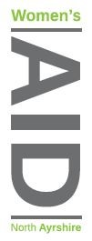
6th March 2026

Dear Applicant
Thank you for your interest in working with North Ayrshire Women’s Aid.
Please find enclosed /downloadable from website:
- An Application Form
- Job Description
- Person Specification
- Summary of Terms and Conditions

Please email (preferably) your application by the closing date of midnight on: Sunday 22 March 2026
admin@nawomensaid.co.uk

or post to arrive prior to closing date
‘FAO RECRUITMENT’ to
NAWA,
17 Vernon Street, Saltcoats, KA21 5HE

Please note that we are unable to acknowledge receipt of your application.

Interviews will be held W/C 13 April 26

We will only contact those applicants who are to be invited to interview and thank you again for your interest in our work.

Yours Sincerely

Mary Beglan

Chief Officer

